TEXT & CONTENT TAGS
These tags are heavily used in:
Blogs
Documentation
Markdown rendering
Code snippets
CMS systems

HTML Headings
<h1>Main Title</h1>
<h2>Section</h2>
<h3>Sub-section</h3>

Rules
Only one <h1> per page
Headings define content hierarchy
Do NOT use headings for styling
Google reads headings like a document outline.

HTML Paragraphs
<p>This is a paragraph.</p>
Block-level
Adds margin automatically
Used for normal readable text

HTML Computer Code

Semantic
<pre>
<code>
console.log("Hello World");
</code>
</pre>
Why this is correct:
<code> → means this is programming code
<pre> → means preserve spacing & line breaks
Accessible (screen readers say “code block”)
SEO & tooling friendly
Standard HTML practice

HTML Entities
Entities are used when:
Characters conflict with HTML
Encoding breaks
Character | Entity
< | &lt;
> | &gt;
& | &amp;
" | &quot;
Example:
<p>Use &lt;div&gt; tag</p>

LAYOUT & GROUPING
This separates junior vs senior HTML devs.

Block vs Inline

Block
New line
Full width
Examples:
<div>, <p>, <section>

Inline
Same line
Content width
Examples:
<span>, <a>, <code>
Layout problems usually start here.

<div> (DANGEROUS IF OVERUSED)

What is <div>?
Generic container
No semantic meaning

HTML Layout (OLD vs MODERN)

❌ Old (table / div soup)
<div>
<div>
<div>Header</div>
</div>
</div>

✅ Modern (semantic)
<header>Header</header>
<main>
<section>Content</section>
</main>
<footer>Footer</footer>

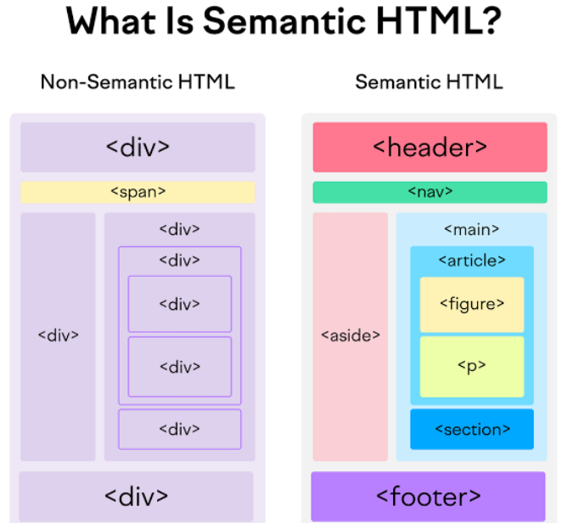

Responsive Layout
HTML supports responsiveness by:
Semantic structure
Logical grouping
CSS handles:
Media queries
Flex/Grid
HTML must be clean, CSS makes it responsive.

SEMANTIC TAGS
These tags give meaning, not style.

<header>
Top of page or section
Logo, title, actions
<header>
<h1>Blog</h1>
</header>

<nav>
Navigation links
<nav>
<a href="/">Home</a>
</nav>

<main>
Main content
Only one per page
<main>
Page content
</main>

<section>
Logical grouping of content
<section>
<h2>Features</h2>
</section>

<article>
Independent content
Blog post, news, card
<article>
<h2>Post title</h2>
</article>
Article should make sense on its own.

<aside>
Related but secondary content
<aside>
Related links
</aside>

<footer>
Bottom content
Copyright, links
<footer>
© 2026
</footer>

DIV SOUP
❌ Bad:
<div class="header"></div>
<div class="nav"></div>
<div class="content"></div>
<div class="footer"></div>
✅ Good:
<header></header>
<nav></nav>
<main></main>
<footer></footer>
Senior principle
“If a semantic tag exists, use it. Use div only when nothing fits.”

